**Press Kit**

Press Kit

About BlueAlly

BlueAlly is a leading IT services and solutions provider that helps clients reduce complexity and harness the power of technology to improve organizational outcomes. With over 450+ highly skilled professionals, 2,000+ industry certifications and 10,000+ satisfied customers served, BlueAlly is a trusted partner known for turning complex technical challenges into strategic business opportunities.

**Fast Facts:**

BlueAlly is on a rapid growth trajectory, boasting a national presence, a highly skilled team and a diverse client portfolio:

**Founded:**

**2013**

**Headquarters:**

**Cary, NC**

with additional offices nationwide.

**Employees:**

**450+**

**Industry Certifications:**

**2,000+**

including Palo Alto: PSNCE, VMware: NSX, Azure, AWS, Aruba, Fortinet, Checkpoint and Cisco: CCDE and CCIE.

**Customers:**

**10,000+**

Founded in 2013, BlueAlly is headquartered in Cary, NC with an established nationwide footprint. The industry heavy-hitter has grown organically and achieved the strategic acquisition of multiple renowned technology brands, such as NetCraftsmen, n2grate, Corporate Armor and more—diversifying its service offerings and expanding its network of partners and suppliers.

The IT innovator delivers cutting-edge solutions for security, compliance, data center, cloud, application development and modernization, workforce collaboration, DevOps, automation and advanced networking to a variety of industries, including government, education, healthcare, finance and others. BlueAlly also boasts a deep bench of subject matter experts, such as John Kavanaugh, an internationally recognized and distinguished Cisco engineer or its broad and highly experienced leadership team that includes former C-suite executives, tech firm founders and industry-renowned IT thought leaders.

BlueAlly is a Cisco Gold Partner with advanced specializations in collaboration, data center, enterprise networks and security architectures. The company has also received multiple awards and recognitions for its outstanding performance and customer satisfaction, such as Cisco’s Federal Software and Services 2023 Partner of the Year, SonicWall's DMR Partner of the Year and Hewlett Packard's Enterprise SLED East Growth Partner of the Year as well as coveted listings on the Inc. 5000 Fastest-Growing Companies, CRN MSP500, CRN Elite 150, CRN Solution Provider 500 and more.

BlueAlly works with some of the most prestigious and influential organizations in the world, such as the Social Security Administration, Sysco Foods, NASA, AMC Theaters, Verizon and many more. Its portfolio of success stories showcases its ability to deliver IT solutions that meet the highest standards of quality, security and efficiency.

The company’s mission is to help clients conquer complexities by making technology more accessible, more certain and more impactful for every organization. It ensures businesses are fully equipped to access best-of-breed technology that drives key organizational outcomes and fuels progress. BlueAlly is committed to elevating clients with the technology they need to scale confidently while providing dedicated 24/7/365 support to create an environment where businesses can thrive on innovation. BlueAlly is more than just an IT services and solutions provider. It is a true ally in client IT maturity journeys.

Brand Ethos

BlueAlly is more than just a leading IT services and solutions provider, it is a true ally to its clients.

|  |  |
| --- | --- |
| **Mission:** | To create innovative solutions with unmatched expertise to solve client business challenges. |
| **Vision:** | To enable clients to achieve their business potential by serving as a trusted technology provider, valued partner and employer of choice. |
| **Values:** | BlueAlly's values are not just principles; they serve as the compass guiding it toward ongoing excellence:   * **Teamwork:** BlueAlly takes pride in building bridges and enabling connection, understanding that its shared history and diversity bring great strength. * **Integrity:** It ensures that building trust is at the heart of everything that it does. * **Commitment:** It follows through and maintains a strong say-do ratio, always striving to deliver on its promises. * **Forward Looking:** It embraces change, remaining agile and ready for what’s next, always innovating and seeking growth. * **Balance:** It fosters a positive, empowering environment and believes that peak performance requires overall wellness and work-life harmony. |

Industries Served

BlueAlly serves a diverse range of industries and clients, from small businesses to Fortune 100 companies who want to harness the power of technology to improve their business outcomes. It has extensive experience and knowledge in delivering innovative and reliable IT solutions for the **education, energy, utilities, finance, government, healthcare, manufacturing, media, entertainment, retail, telecom** and **broadband** sectors, including preferred partnerships with top media corporations, the world’s top communications firm, one of the nation’s largest credit unions and the world’s largest power management company. It also has the clearances, skills, experience and brand relationships to deliver secure, robust and scalable IT solutions that meet and exceed the needs of the public sector, from local to national government – boasting deeply established relationships with the Department of Defense, the Department of Justice, the Department of Homeland Security, the Department of Health and Human Services and others.

Certifications and Partner Accolades

BlueAlly holds over **2,000+ industry certifications**, demonstrating its expertise and excellence in a powerful array of technologies and domains. A **Cisco Gold Partner** with advanced specializations in collaboration, data center, enterprise networks and security architectures, BlueAlly has received numerous accolades from Cisco, such as the Mid-Atlantic Partner of the Year, the Federal Civilian Partner of the Year, the Federal Innovation Challenge Finalist and the Launch Partner at its WebexOne Event. The firm also has key certifications from other leading technology partners such as **Palo Alto, VMware, Azure, AWS, Aruba, Fortinet, Checkpoint** and others. These certifications enable BlueAlly to deliver innovative and reliable IT solutions for cloud, cybersecurity, automation and more, across various industries and sectors.

Notable Clients

BlueAlly serves a diverse range of clients, ranging from small businesses to Fortune 500 companies and government agencies. It has a robust and varied client portfolio with thousands of brands including household names like **NBCUniversal, Disney, ViacomCBS, AT&T, Navy Federal Credit Union, Eaton, Lululemon, AMC Theatres** and more. The company delivers cutting-edge IT solutions that help these clients scale, optimize and manage their IT resources to overcome their technical challenges and reach their business goals.



Key Partnerships

BlueAlly has established strong partnerships with premium technology vendors, including some of the most prominent names in the industry, such as **Cisco, Microsoft, Amazon Web Services, Oracle, Adobe, VMware, Dell** and more. These relationships enable BlueAlly to access the latest technologies, best practices and solution architectures, as well as direct support and guidance from manufacturers. BlueAlly is an authorized partner of providers, such as **Red Hat, Fortinet, Nutanix, Proofpoint** and more, which allow it to offer competitive pricing, flexible delivery and customized solutions to its clients. Its world-class array of partnerships gives BlueAlly a unique advantage in the IT industry, allowing the company to remain tech-agnostic and deliver innovative, reliable IT solutions that meet the diverse needs of its clients.

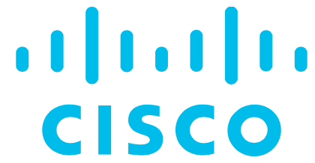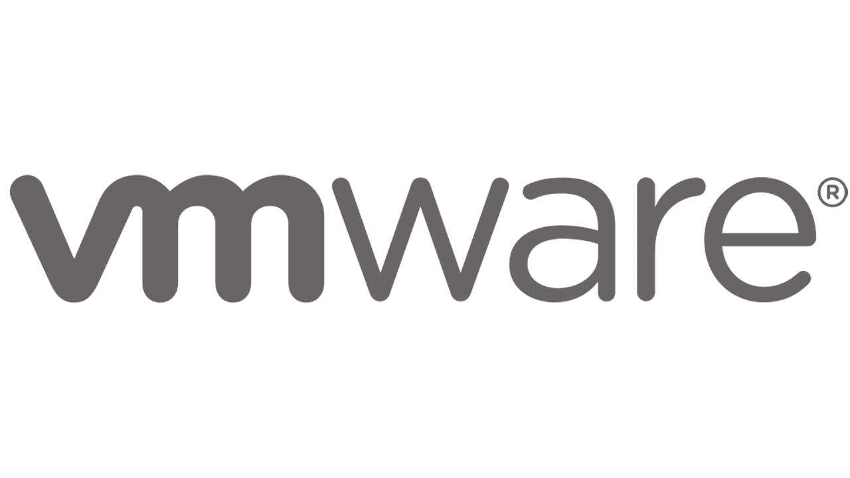

Industry Awards

BlueAlly has earned acclaim from some of the most influential publications and organizations globally, recognizing its outstanding performance and customer satisfaction both independently and through its acquired organizations.

Over the last decade, BlueAlly's accolades include making the **Elite 150 MSP List by CRN**, securing the **DMR Partner of the Year Award from SonicWall,** achieving **Triple Crown Winner status from CRN,** being named in the **Solution Provider 500 by CRN,** receiving the **SMB Partner of the Year distinction from Aruba**, earning the **Rising Star Partner of the Year title from Veeam**, and being honored as the **Mid-Atlantic Partner of the Year, Federal Civilian Partner of the Year, Federal Innovation Challenge Finalist** and **Launch Partner at the WebexOne Event by Cisco**. Additionally, BlueAlly has been recognized as the **SLED East Growth Partner of the Year by HPE** and **Partner of the Year by Riverbed**, among other notable awards.

These accomplishments, coupled with BlueAlly being ranked among the **Inc.** **5000 fastest-growing private companies** in the U.S. for six consecutive years, named one of the **CRN Solution Provider 500** top IT solution providers in the U.S.and certified as a **Microsoft Solutions Partner: Infrastructure; Modern Work; Digital & App Innovation,** a **Cisco Premier Partner** and a **VMware Enterprise Partner**, underscore the company's excellence across technologies and domains.

These recognitions solidify BlueAlly's competitive edge, establishing a robust reputation in the IT industry and reinforcing the high level of trust and loyalty it holds from both customers and partners. BlueAlly is not just an IT service and solution provider; it is a true champion within its industry.



**2023**

**2022**

**2021**

**2020**

**2018**



**2022**

**2018**

**2019**

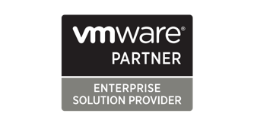

Burgeoning Growth

BlueAlly is a leading provider of IT solutions and services that help clients achieve their business goals and optimize organizational performance. Founded in 2013, BlueAlly has grown from a small IT consulting firm to a full-service IT partner with a nationwide presence employing a powerhouse team of 450+ technical experts. After a proven track record of impressive organic- and acquisition-driven growth, BlueAlly linked up with Source Capital in 2020 which set in motion a growth trajectory that includes the M&A-based integration of a total of six tech companies that are currently unified as one well-rounded IT juggernaut on a deliberate mission to make technology more accessible, more certain and more impactful for every organization it serves. Key acquisitions include:

**2016**

**2017**

**2020**

**2021**

**2023**

**2024**

**2015**

**2013**

**2018**

**2019**

**2022**

**Net Direct Systems, LLC**

A leading cloud and network solutions provider offering comprehensive and customized services for the commercial and public sectors.

**Syscom Technologies**

A trusted partner for data storage, backup and recovery solutions leveraging cutting-edge equipment and processes to deliver complex electronics development and manufacturing.

**IQ Global Technologies MSSP Platform**

A platform for managed security services enabling organizations to monitor, detect and respond to cyber threats in real-time with advanced analytics and automation.

**JMA IT**

A provider of IT staffing, consulting and project management services helping clients solve their IT challenges with innovative and scalable solutions across various platforms and devices.

**Core2Cloud**

A cloud migration, management and optimization service provider helping clients achieve cost savings, greater availability, predictability and governance for their IT infrastructure.

**Virtual Graffiti**

A hybrid e-commerce platform offering a wide range of security, wireless and data storage products from industry-leading brands, along with expert consultation and support.

**NetCraftsmen**

An industry leader providing consulting, solutions design and ongoing management for cloud, automation, security, network, computing, storage and collaboration technologies, with a focus on security and quality.

**n2grate**

A data center and cloud integration company specializing in hardware, software, training and professional and cloud services for the public sector and large business clients, with a robust portfolio of end-to-end solutions.

**Corporate Armor**

A supplier of technology security and infrastructure products offering one of the largest curated selections of security, wireless and data storage products online and through an inside sales team, with a white-glove experience and exceptional client service.

**B2B Technologies**

A Microsoft Cloud Partner in multiple solution areas providing business productivity solutions using Azure, SharePoint, Teams, Power BI and Microsoft 365, with a mission to help clients improve productivity, reduce risk and maximize their IT investments.

**Strata Consulting**

A provider of IT strategy, governance and transformation services helping clients align their IT vision and goals with their business objectives and implement best practices and solutions to optimize their IT performance and value.

Core Services and Solutions

BlueAlly has established itself as an IT industry force to be reckoned with, offering a comprehensive range of solutions and services that cover the entire IT lifecycle.

|  |  |  |
| --- | --- | --- |
| **Security**  BlueAlly stands at the forefront of cybersecurity innovation, offering a comprehensive suite of services tailored to ensure unparalleled protection of clients' most important business data. |  | * Identity & Access Management (IAM) * Managed Security & Professional Services * Network Security Strategy & Solutions * Security Architecture & Engineering * Security Assessments * Security Testing Services * Zero Trust Strategy & Solutions |
| **Compliance**  BlueAlly offers a comprehensive range of solutions to help organizations stay in lockstep with regulatory standards and industry compliance requirements. The company offers dedicated support and guidance for clients as they navigate the complexities of certifications including SOC 2, ISO 27001, FedRAMP, CMMC, PCI, HIPPA, HITRUST and TISA. |  | * Cloud Compliance * Compliance Assessments * Compliance Readiness & Remediation * Compliance Staff Augmentation * Information Security Policy Development * Internal Audits * Managed Compliance * Security Framework Implementation |
| **Cloud**  BlueAlly excels in cloud services, offering a robust suite of solutions and expertise to ensure organizations transition to or maintain the cloud in a smooth, effective and secure manner that minimizes risks and maximizes performance and cost-effectiveness. |  | * Application Modernization * Cloud Networking * Cloud Optimization & Cost Visibility * Cloud Security * Cloud Strategy & Design * Data Analytics * Managed Cloud |
| **Application Development & Modernization**  With over 200 custom applications built and upgraded, BlueAlly is an authority in app modernization—successfully transforming legacy IT systems and optimizing and developing apps that keep enterprises at the forefront of their industries. |  | * Application Architecture Review * Application Delivery Optimization * Cloud-Native & Containerization * Custom App Development |
| **Collaboration**  A premier provider of collaborative technology solutions that meet the needs of today’s diverse workforce models, BlueAlly offers a wide range of services that transform the way client businesses communicate, connect and succeed. |  | * Cisco & Microsoft 365 UC&C Services * Contact Centers * Endpoint Staging & Deployment * Managed VoIP * Microsoft 365 Training * Migration Services |
| **DevOps & Automation**  BlueAlly aligns technology with clients' core business objectives, using the power of DevOps to accelerate and enhance software delivery and future-proof business infrastructures. It combines best-of-breed technology with expert decision-making, allowing customers to shift their organizational infrastructure from a challenge into a catalyst for continued growth. |  | * Application Delivery Optimization * DevSecOps Integration * Infrastructure Provisioning & Automation * Internal Development Platforms * Networking Automation * Observability * SREaaS * Well-Architected Assessment & Implementation |
| **Networking**  BlueAlly's state-of-the-art technology solutions and services are tailored to ensure client network infrastructures are primed for both current and future success. Its consultants are domain experts with certifications from industry authorities like Cisco, Azure, AWS and more with a proven track record of delivering comprehensive, customized solutions that support ongoing success. |  | * Data Center Networking * Governance, Risk & Compliance (GRC) * Implementation Services * Lifecycle Services * Network Architecture * Network Assessments * Professional Services * SD-Wan Capabilities * Service Provider Networking * Unified Network Communications * WAN Optimization |
| **Telecom & Broadband**  As a leader in network solutions, BlueAlly is skillful in transforming intricate telecom and broadband challenges into streamlined, efficient systems by empowering businesses with tailored optical transport and network infrastructure solutions. |  | * Analytics & Reporting * Disaster Recovery & Redundancy * Integration & Deployment * Network Performance & Cost Optimization * Scalability & Futureproofing * Security & Compliance * Solution Design & Architecture * Staging Services * Training & Knowledge Transfer |
| **Managed Services**  BlueAlly is a trusted partner, offering businesses a streamlined solution for IT challenges. Its tailored approach, with flexible service tiers, bridges knowledge and workforce gaps and delivers premium technologies within budget constraints. |  | * Managed Security * Managed Infrastructure * Managed Cloud |
| **Professional Services**  BlueAlly blends broad experience with deep insight, tailoring its professional services to meet specific enterprise needs. Leveraging world-class IT talent and proven processes that enable businesses to maximize the potential of their tools, BlueAlly efficiently implements high-value solutions while minimizing downtime of critical systems. |  | * Assessment Services * Implementation Services * Migration Services * Service Providers * Integration Center * Workforce Transformation * Cloud Services |



Executive Leadership

BlueAlly has a strong leadership team rooted in broad professional experience and a passion for delivering customized, value-added IT solutions and services that support sustained client success.

**George Barkley -** Chief Executive Officer

George Barkley has served as the CEO of BlueAlly since May 2021, bringing a wealth of experience and a distinguished professional background to the role. With a 25-year track record of success in the IT industry, Barkley has held key positions with esteemed companies such as IBM and EMC and is renowned for his transformational leadership style. A career highlight includes founding and managing Sovereign Systems, an Atlanta-based solution provider that was acquired by Ahead in 2019; and other remarkable achievements include steering BlueAlly’s growth from a regional $100 million reseller to a national solutions provider with nearly $1 billion in sales. Barkley oversees the strategic design, direction and success of BlueAlly while mobilizing and enabling leadership teams and engaging stakeholders. His vision is to position BlueAlly as a leading force in the industry. Barkley earned a bachelor’s degree in business administration from the University of Georgia Terry College of Business and an MBA from Emory University Goizueta Business School.



**David Coulter -** Chief Technology Officer

In his role as chief technology officer, David Coulter is responsible for the company’s overall technical go-to-market and internal technology strategies, including leading solutions policy, solutions engineering, IT and internal development efforts. Coulter's career has spanned a range of challenging roles, from technical expert to C-level executive while managing globally distributed teams. Notably, he co-founded and led a cloud management and automation software company to a successful exit, showcasing his strategic governance and entrepreneurial skills. As CTO, Coulter’s organizational goals are centered around redefining the role of the modern solutions provider by driving technology innovation and enhancing customer experiences—positioning BlueAlly at the forefront of the tech services industry.



**Ian Duam -** Chief Revenue Officer

As chief revenue officer, Ian Daum is responsible for the expansion and maturation of BlueAlly’s sales organization. Boasting a history of high-level roles with AHEAD and Sovereign Systems, a bachelor’s in engineering physics and an MBA in finance and strategy, he has been a driving force in BlueAlly’s overarching corporate go-to-market strategy. Daum is focused on fostering a creative, entrepreneurial culture that prioritizes long-term customer relationships and client service excellence. His executive vision is to see BlueAlly continue to evolve into a more modern, thoughtful and accountable version of the traditional technology partner—and be seen as an industry leader in innovation, authenticity and responsibility.



**Jonathan Berger -** Chief Marketing Officer

As chief marketing officer, Jonathan Berger has played a pivotal role in BlueAlly’s growth since joining its C-suite in 2021. Bringing a wealth of experience as the former CEO of Saicom Voice Services and COO of Virtual Graffiti, Berger holds an MBA along with a master’s and bachelor’s in electrical engineering. In his current role, he has been instrumental in strategically directing and executing the company’s 2023 rebranding efforts, crafting a comprehensive digital commerce strategy and transforming the organization into a leading digital marketing entity. Known for his collaborative and empowering leadership style, Berger aims to unify the organization’s continued acquisitions under a cohesive brand and culture, establishing BlueAlly as a respected and dynamic name in the industry.



**Maria Will -** Senior Vice President, Telecom & Broadcast

Maria Will, senior vice president of telecom and broadband at BlueAlly, has dedicated six years to the organization, previously serving as its vice president of technology solutions. In her current role, Will is responsible for driving growth and strategy in the telecom and broadband division, expanding hardware and professional services solutions across diverse markets. With over 30 years of leadership in technology solutions, she has played crucial roles in various companies across the U.S., specializing in selling and implementing cutting-edge optical and network technology solutions. Armed with a bachelor’s degree in business administration with an emphasis in marketing, her leadership philosophy revolves around empowering individuals to take ownership and drive organizational growth. Her current priorities include integrating advanced IT solutions with sales strategies to achieve a 20% revenue growth, solidifying BlueAlly’s position as an industry leader.



Press Opportunities

BlueAlly boasts a full roster of dynamic, highly certified technical experts and insightful executives available to discuss a variety of topics spanning IT, security, governance, compliance, infrastructure, cloud, automation and more. Subject matter experts are readily available for interviews and can provide contributed insights or articles.

Contact

BlueAlly is committed to delivering IT solutions and services that help clients succeed in the digital age.

Contact us to learn more.

|  |  |  |  |
| --- | --- | --- | --- |
| Building outline | **Headquarters:**  1225 Crescent Green Ste. 115, Cary, NC 27518 | Receiver outline | **Phone:**  800.866.5369 |
| Envelope outline | **Email:**  contact@blueally.com | Internet outline | **Website:**  blueally.com |
| Office worker female outline | **Media Contact:**  Leslie Licano | blueally@beyondfifteen.com | 949.733.8679 x 101 | | |
| Double Tap Gesture outline | **Social Media:**  Follow **BlueAlly** on [LinkedIn](https://www.linkedin.com/company/blueally/), | | |